
Business Question and Visualization Report
Date | 21-09-2026
Team ID | Master of Computer Applications(MCA)
Project Name | Online Education Student Engagement, Performance & Dropout Analysis
Maximum Marks | 5 Marks

Visualization development refers to the process of creating graphical representations of data to facilitate understanding, analysis, and decision-making. The goal is to transform complex datasets into visual formats that are easy to interpret, enabling users to gain insights and make informed decisions. Visualization development involves selecting appropriate visual elements, designing layouts, and using interactive features to enhance the user experience. This process is commonly associated with data visualization tools and platforms, and it plays a crucial role in business intelligence, analytics, and reporting.
Business Questions and Visualisation
The process involves defining specific business questions to guide the creation of meaningful and actionable visualizations in Power BI. Well-framed questions help in identifying key metrics, selecting relevant data, and building visualisations that provide insights. The ten questions below are answered using the online education dataset (32,593 students); each chart mirrors a visual built in the accompanying Power BI dashboard (sushma.pbix).
1. How many students passed versus dropped out overall?
Visualization: Bar chart comparing total students who passed vs. dropped out.
Screenshot of visualisation:
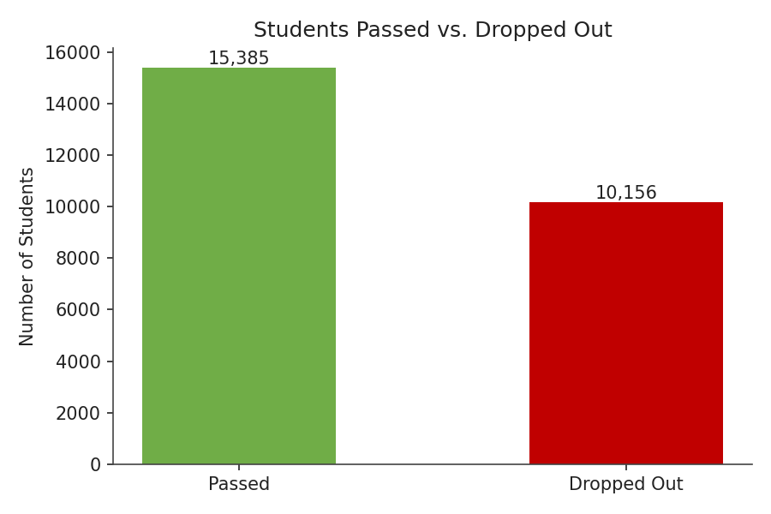
2. How are students distributed across engagement levels?
Visualization: Bar chart of student count by engagement level (Low/Medium/High).
Screenshot of visualisation:
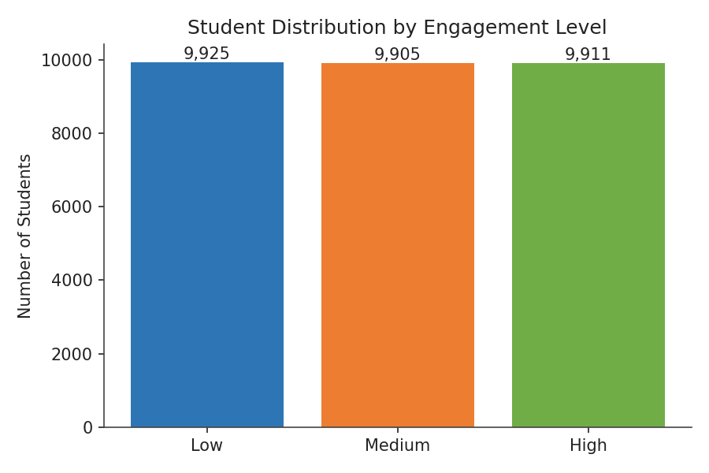
3. How are students distributed across performance levels, and what's the average score in each?
Visualization: Bar chart of student count by performance level, labeled with average score.
Screenshot of visualisation:
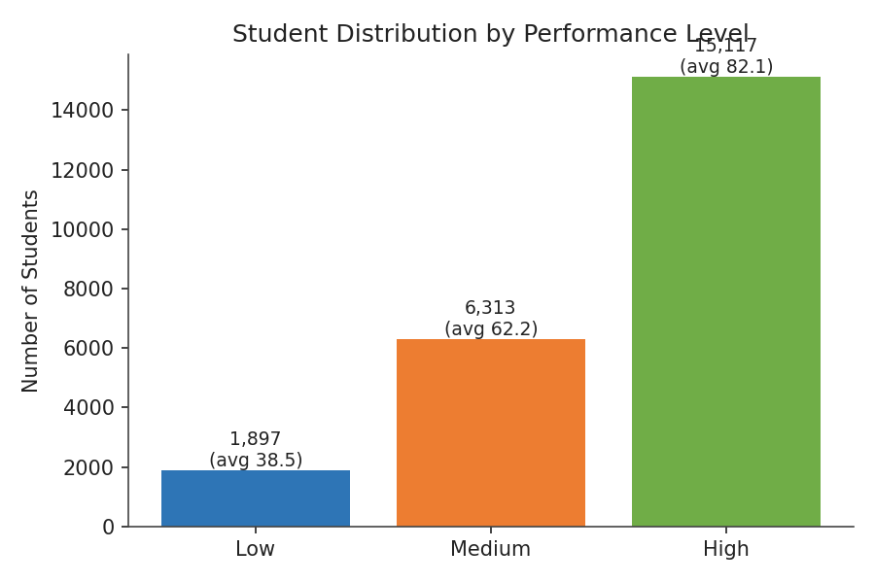
4. How are students distributed across risk levels?
Visualization: Bar chart of student count by risk level (Safe, Low, High, Very High Risk).
Screenshot of visualisation:
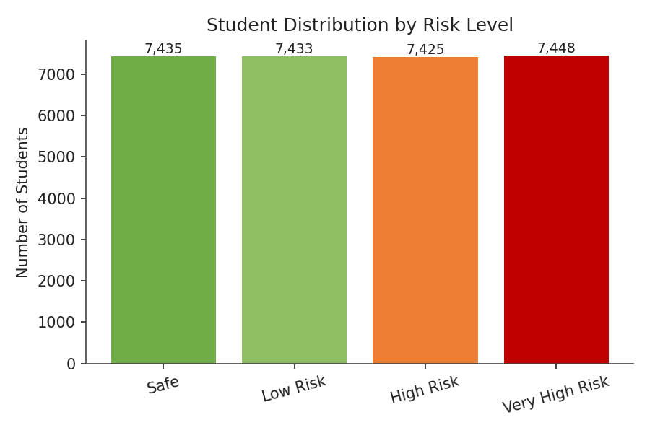
5. How does engagement level relate to average score?
Visualization: Bar chart of average score by engagement level.
Screenshot of visualisation:
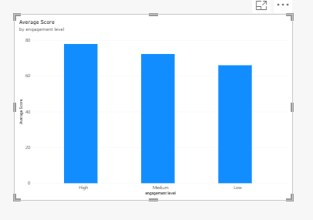
6. How does total click volume relate to average score?
Visualization: Line chart of average score across click-volume bands (0-500 up to 3000+).
Screenshot of visualisation:
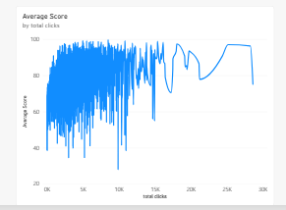
7. Which engagement level has the highest dropout rate?
Visualization: Bar chart of dropout rate (%) by engagement level.
Screenshot of visualisation:
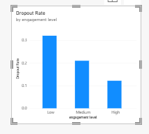
8. Which performance level has the highest dropout rate?
Visualization: Bar chart of dropout rate (%) by performance level.
Screenshot of visualisation:
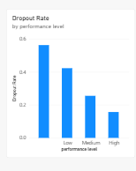
9. How do regions compare in total number of students?
Visualization: Horizontal bar chart of total students by region.
Screenshot of visualisation:
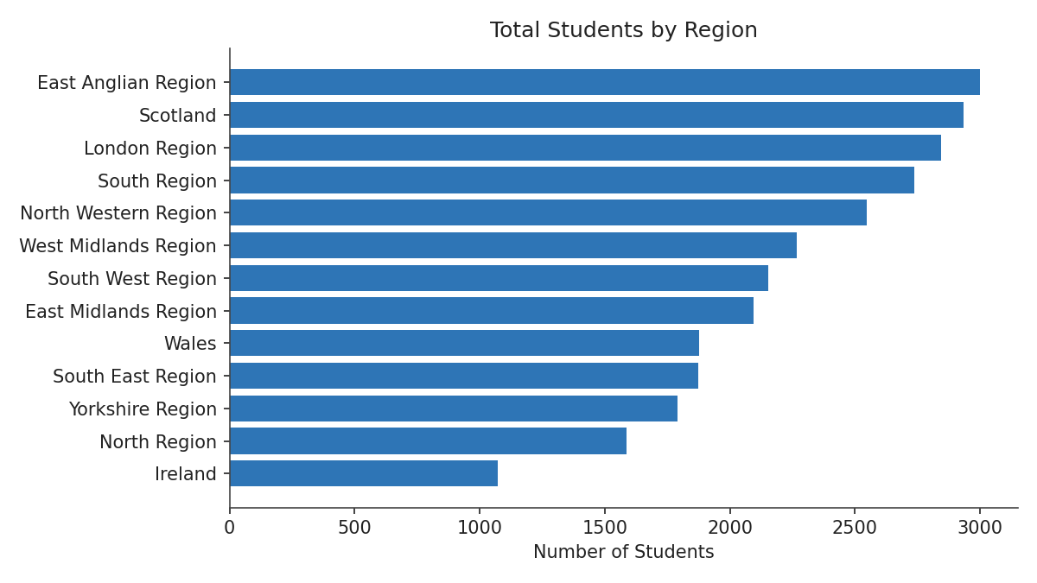
10. How does prior educational background affect average score?
Visualization: Bar chart of average score by highest prior education level.
Screenshot of visualisation:


